 |  | RTAS 2006  April 4 - April 7, 2006  San Jose, California, United States
Wednesday, April 5, 2006: All meetings in Crystal Room
8:00 | Continental breakfast & registration
8:45-9:00 | Welcome by symposium chairs
9:00-10:00 | Keynote by Dr. Douglas C. Schmidt, Vanderbilt University  Meeting the Challenges of Ultra-Large-Scale Real-time Systems
10:00-10:30 | Coffee break
10:30-12:00  Session 1: Real-Time  Operating Systems  Chair: John Regehr | APPLICATION-SPECIFIC SERVICE TECHNOLOGIES FOR COMMODITY OPERATING SYSTEMS IN REAL-TIME ENVIRONMENTS  Richard West and Gabriel Parmer  PREDICTABLE INTERRUPT MANAGEMENT FOR REAL TIME KERNELS OVER CONVENTIONAL PC HARDWARE  Luis E. Leyva-del-Foyo, Pedro Mejia-Alvarez, and Dionisio de Niz  MEMORY FOOTPRINT REDUCTION WITH QUASI-STATIC SHARED LIBRARIES IN MMU-LESS EMBEDDED SYSTEMS  Jaesoo Lee, Jiyong Park, and Seongsoo Hong
12:00-1:30 | Lunch break
1:30-3:30  Session 2: Resource Management  Chair: Ying Lu | GRANULARITY AWARE (M,K) QUEUE MANAGEMENT FOR REAL-TIME MEDIA SERVERS  Yingxin Jiang and Aaron Striegel  FSF: A REAL-TIME SCHEDULING ARCHITECTURE FRAMEWORK  M. Aldea, G. Bernat, I. Broster, A. Burns, R. Dobrin, J. M. Drake, G. Fohler, P. Gai, M. González Harbour, G. Guidi, J.J. Gutiérrez, T. Lennvall, G. Lipari, J.M. Martínez, J.L. Medina, J.C. Palencia, M. Trimarchi  ZYGARIA: STORAGE PERFORMANCE AS A MANAGED RESOURCE  Theodore M. Wong, Richard Golding, Caixue Lin, and Ralph Becker-Szendy  METERG: MEASUREMENT-BASED END-TO-END PERFORMANCE ESTIMATION TECHNIQUE IN QOS-CAPABLE MULTIPROCESSORS  Jae W. Lee and Krste Asanovic, MIT Computer Science and Artificial Intelligence Laboratory (CSAIL), Cambridge, MA 02139, U.S.A.
3:30-4:00 | Coffee break
4:00-5:30  Session 3: Scheduling  Chair: Marco Di Natale | INTERACTIVE SCHEDULABILITY ANALYSIS  Unmesh D. Bordoloi and Samarjit Chakraborty  UNIPROCESSOR SCHEDULING UNDER PRECEDENCE CONSTRAINTS  Leonardo Mangeruca, Massimo Baleani, Alberto Ferrari, Alberto Sangiovanni-Vincentelli  ON NON-UTILIZATION BOUNDS FOR ARBITRARY FIXED PRIORITY POLICIES  Xue Liu and Tarek Abdelzaher
6:30-8:30 | Conference Banquet

Thursday, April 6, 2006: Meetings in Empire (A Sessions) and Garden (B Sessions) Rooms
except the Joint ESC Panel, which is at the Civic Auditorium
8:00 | Breakfast & registration
8:30-10:30 | Parallel Sessions
Session 4A: Distributed and Multiprocessor Scheduling  Chair: Dakei Zhu (Empire Room)  REAL-TIME SCHEDULING ON MULTICORE PLATFORMS  James H. Anderson, John M. Calandrino, UmaMaheswari C. Devi  A DECOUPLED SCHEDULING APPROACH FOR DISTRIBUTED REAL-TIME EMBEDDED AUTOMOTIVE SYSTEMS  Shengbing Jiang  TASK PARTITIONING WITH REPLICATION UPON HETEROGENEOUS MULTIPROCESSOR SYSTEMS  Sathish Gopalakrishnan and Marco Caccamo  ADAPTIVE ALLOCATION OF SOFTWARE AND HARDWARE REAL-TIME TASKS FOR FPGA-BASED EMBEDDED SYSTEMS  Rodolfo Pellizzoni and Marco Caccamo |  | Session 4B: Design and Development  Chair: Vana Kalogeraki (Garden Room)  INCORPORATING SCENARIOS AND HEURISTICS TO IMPROVE FLEXIBILITY IN REAL-TIME EMBEDDED SYSTEMS  Iain Bate and Paul Emberson  MODEL-BASED DEVELOPMENT OF EMBEDDED SYSTEMS: THE SYSWEAVER APPROACH  Dionisio de Niz, Gaurav Bhatia, and Raj Rajkumar  INTERFACE-BASED DESIGN OF REAL-TIME SYSTEMS WITH HIERARCHICAL SCHEDULING  Ernesto Wandeler and Lothar Thiele  AN INTERFACE ALGEBRA FOR REAL-TIME COMPONENTS  Thomas A. Henzinger, Slobodan Matic
10:30-11:00 | Coffee Break
11:00-12:00 | ESC Floor Exhibits or Sponsored Seminars at Convention Center
12:00-1:30 | Lunch break
1:30-3:00 | Parallel Sessions
Session 5A: Sensor Networks  Chair: Hakan Aydin (Empire Room)  ACHIEVING REAL-TIME TARGET TRACKING USING WIRELESS SENSOR NETWORKS  Tian He, Pascal A. Vicaire, Ting Yan, Liqian Luo, Lin Gu, Gang Zhou,  Radu Stoleru, Qing Cao, John A. Stankovic and Tarek Abdelzaher  SCALABLE MODELING AND PERFORMANCE EVALUATION OF WIRELESS SENSOR NETWORKS  YoungMin Kwon and Gul Agha  IMPACT OF UPPER LAYER ADAPTATION ON END-TO-END DELAY MANAGEMENT IN WIRELESS AD HOC NETWORKS  Wenbo He and Klara Nahrstedt |  | Session 5B: Worst Case Execution Analysis  Chair: Chris Healy (Garden Room)  BOUNDING PREEMPTION DELAY WITHIN DATA CACHE REFERENCE PATTERNS FOR REAL-TIME TASKS  Harini Ramaprasad, Frank Mueller  ESTIMATING THE WORST-CASE EXECUTION ENERGY OF EMBEDDED SOFTWARE  Ramkumar Jayaseelan, Tulika Mitra, Xianfeng Li  INTERRUPT TRIGGERED SOFTWARE PREFETCHING FOR EMBEDDED CPU INSTRUCTION CACHE  Ken W. Batcher and Robert A. Walker
3:00-3:30 | Coffee Break
3:30-5:00 | Parallel Sessions
Session 6A: Real-Time Communication  Chair: Tarek Abdelzaher (Empire Room)  SWITCH SCHEDULING AND NETWORK DESIGN FOR REAL-TIME SYSTEMS  Sathish Gopalakrishnan, Marco Caccamo and Lui Sha  MESSAGE REORDERING FOR THE REUSE OF CAN-BASED LEGACY APPLICATIONS IN A TIME-TRIGGERED ARCHITECTURE  R. Obermaisser  NETWORK-CODE MACHINE: PROGRAMMABLE REAL-TIME COMMUNICATION SCHEDULES  Sebastian Fischmeister, Oleg Sokolsky, Insup Lee |  | Session 6B: Modeling  Chair: Alastair Reid (Garden Room)  SCHEDULING ANOMALY DETECTION AND OPTIMIZATION FOR DISTRIBUTED SYSTEMS WITH PREEMPTIVE TASK-SETS  Razvan Racu and Rolf Ernst  OPTIMIZING THE MULTITASK IMPLEMENTATION OF MULTIRATE SIMULINK MODELS  Marco Di Natale  A SEMANTIC UNIT FOR TIMED AUTOMATA BASED MODELING LANGUAGES  Kai Chen, Janos Sztipanovits and Sherif Abdelwahed
5:00-5:30 | Short Break to walk to the Civic Auditorium for the Joint ESC Panel
5:30-6:30  Session 7: Joint ESC Panel at the  Civic Auditorium | Win-Win Partnership of Academia and Industry: Why Should We Care? Where Is Our Common Future?  Moderator: Steve Liu, Panelists: Greg Bollella (Sun), Helen Gill (NSF), Frank Mueller (North Carolina State), and Alastair Reid (ARM), Douglas Schmidt (Vanderbilt), and Douglas Stuart (Boeing)

Friday, April 7, 2006: All meetings in Crystal Room
8:00 | Breakfast & Registration
8:30-9:30  Session 8: Multimedia Performance Analysis  Chair: Marco Caccamo | A PERFORMANCE ESTIMATION TOOL FOR VIDEO APPLICATIONS  Zhengting He, Cheng Peng, Aloysius K. Mok  STATISTICAL PERFORMANCE ANALYSIS OF COARSE GRAIN PARALLEL MULTIMEDIA  PROCESSING SYSTEM  Min Li, Tanja Van Achteren, Erik Brockmeyer, Francky Catthoor
9:30-10:00 | Coffee break
10:00-12:00  Session 9: Work In Progress  WIP Chair: Iain Bate  Session Chair: Ying Lu | Work In Progress  See WIP proceedings for paper titles and authors.
12:00-1:30 | Lunch break
1:30-3:00  Session 10: Embedded and Real-Time Technologies  Chair: Michael Gonzalez Harbour | ROS-DMA: A DMA DOUBLE BUFFERING METHOD FOR EMBEDDED IMAGE PROCESSING  WITH RESOURCE-OPTIMIZED SLICING  Christian Zinner and Wilfried Kubinger  WAIT-FREE QUEUE ALGORITHMS FOR THE REAL-TIME JAVA SPECIFICATION  Philippas Tsigas, Yi Zhang, Daniel Cederman, Tord Dellsen  REAL-TIME JAVA IN AVIONICS APPLICATIONS  Jason Baker, Antonio Cunei, Chapman Flack, Filip Pizlo, Marek  Prochazka, Jan Vitek, Austin Armbruster, Edward Pla, David Holmes
3:00-3:30 | Coffee break
3:30-5:00  Session 11: Energy Awareness  Chair: Scott Brandt | RELIABILITY-AWARE DYNAMIC ENERGY MANAGEMENT IN DEPENDABLE EMBEDDED  REAL-TIME SYSTEMS  Dakai Zhu  LEAKAGE-AWARE ENERGY-EFFICIENT SCHEDULING OF REAL-TIME TASKS IN  MULTIPROCESSOR SYSTEMS  Jian-Jia Chen and Heng-Ruey Hsu and Tei-Wei Kuo  ENERGY-EFFICIENT REAL-TIME HETEROGENEOUS SERVER CLUSTERS  Cosmin Rusu, Alexandre Ferreira, Claudio Scordino, Aaron Watson, Rami  Melhem and Daniel Mosse
5:00 | Concluding Remarks

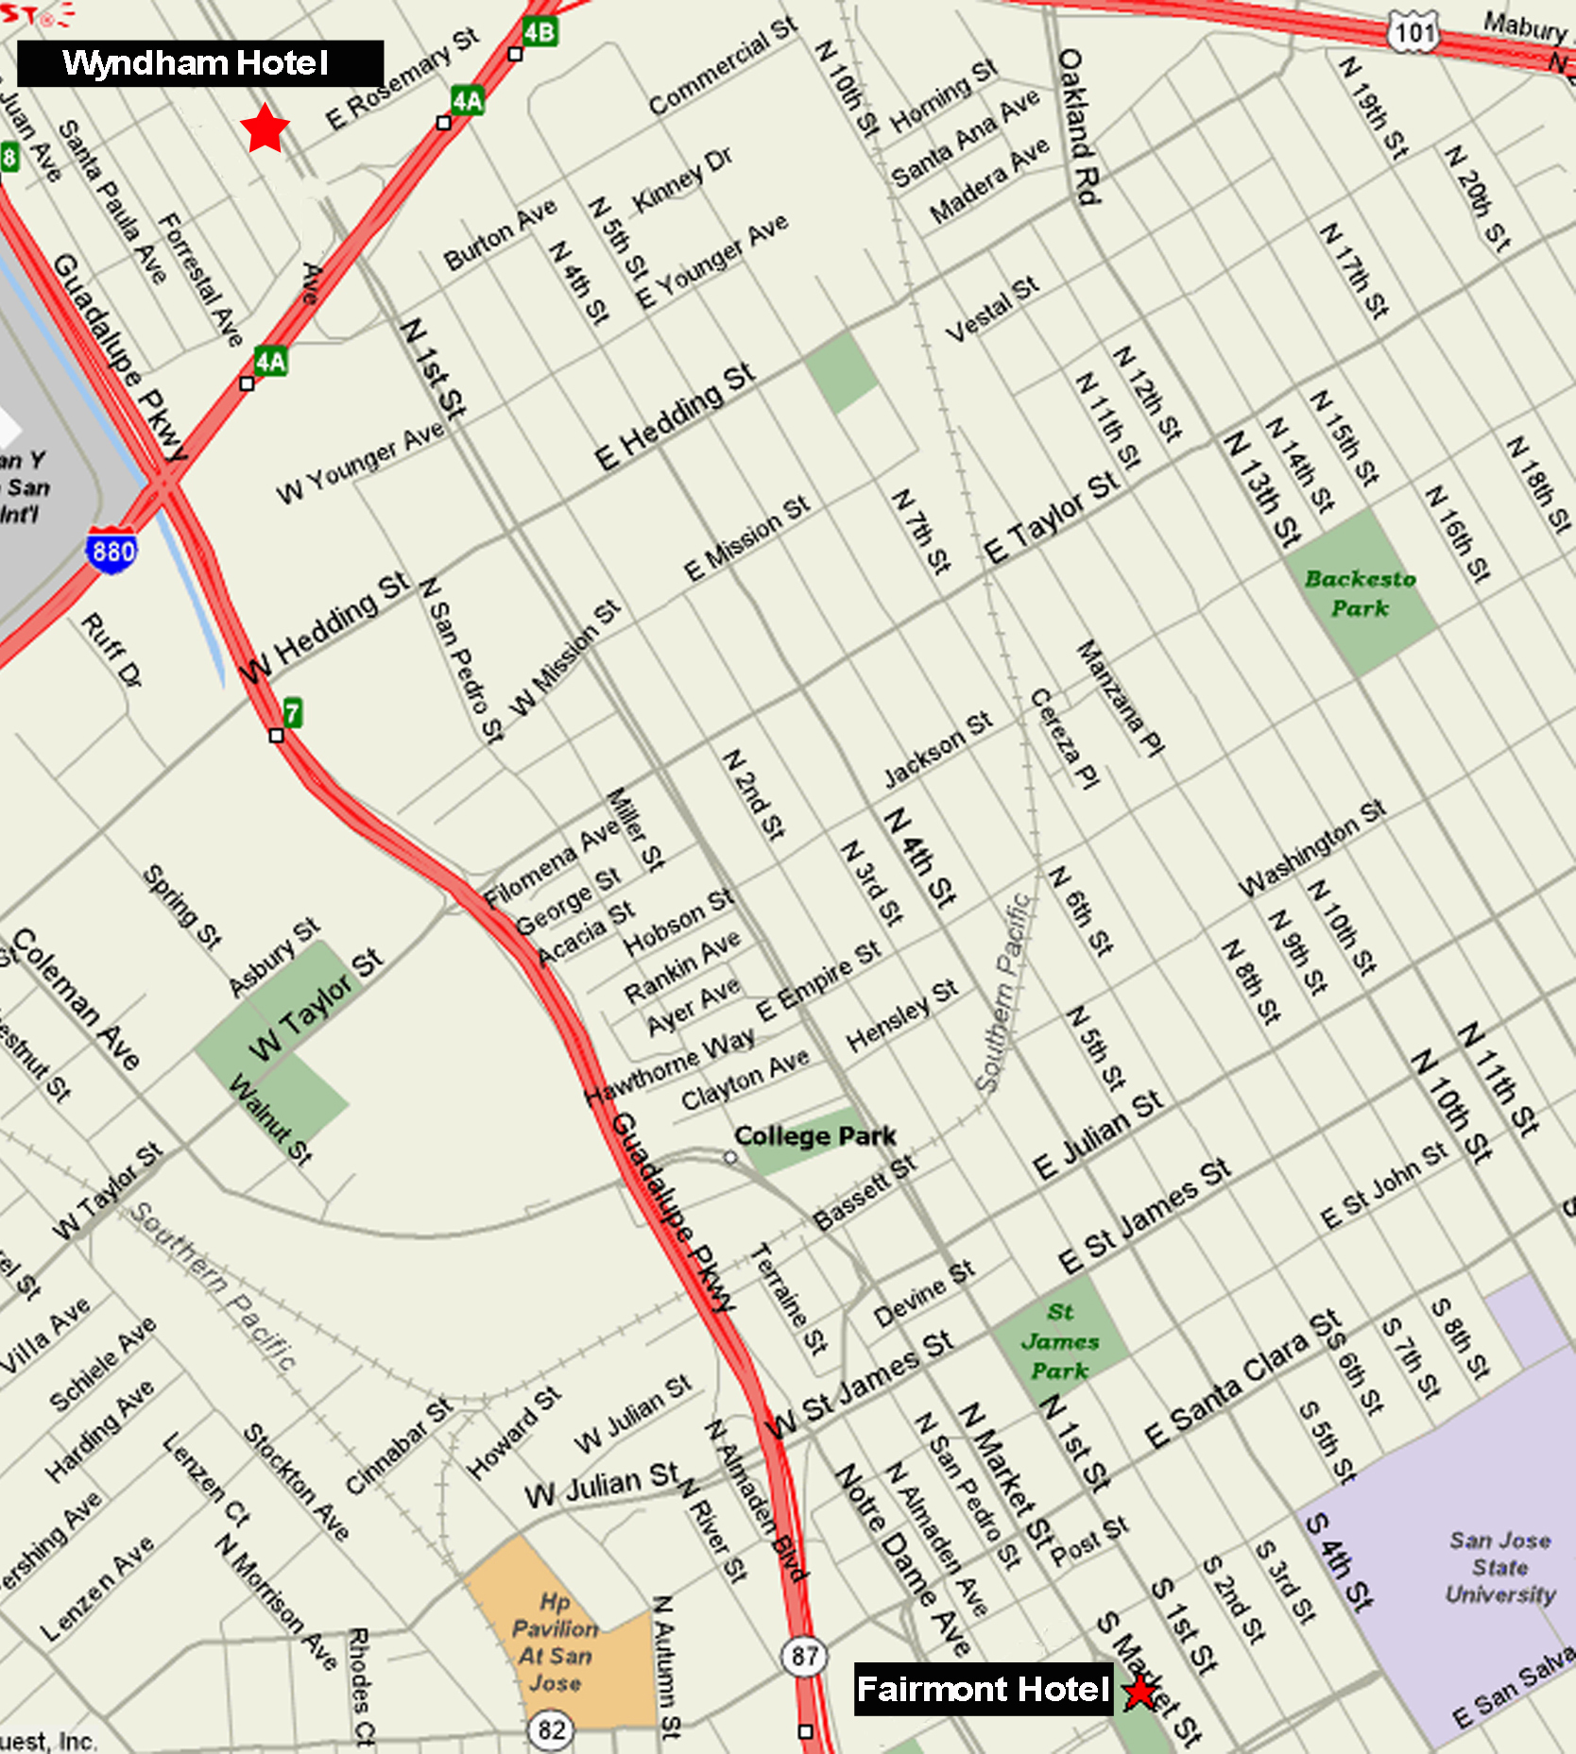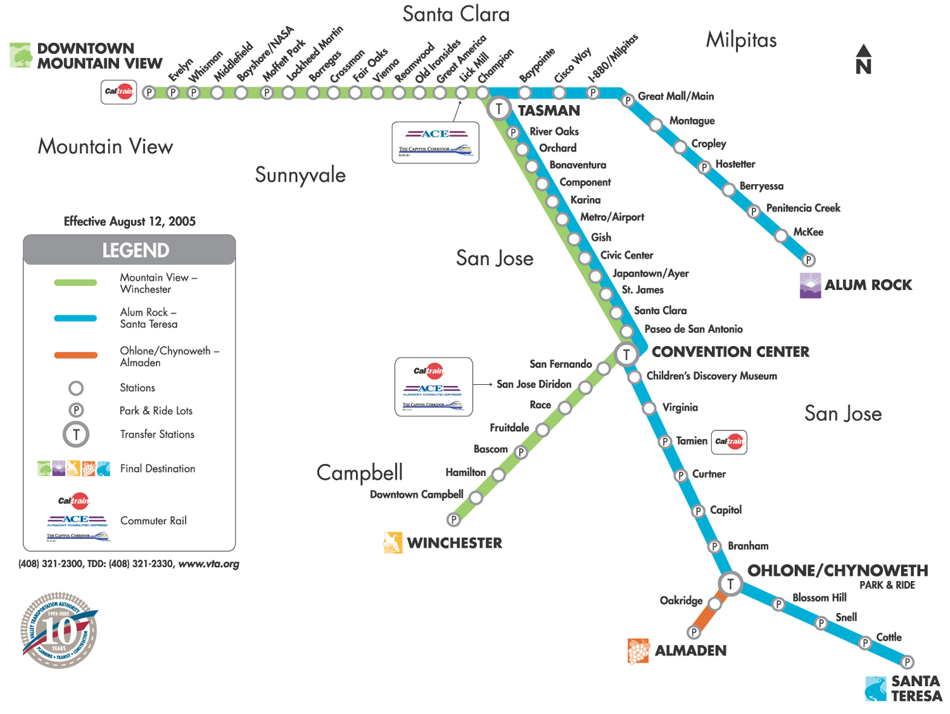

Wyndham Hotel Fairmont Hotel
1350 North 1st St. 170 S. Market St.
San Jose, CA 95112 San Jose, CA 95113
(408) 453-6200 (408) 998-1900

Light Rail Information: Stations, Schedules & Fares

Gish Station - Nearest Station to the Wyndham Hotel
Southbound Route 901 will leave this station approximately every quarter hour (beginning before 6:00 am)
Split platforms in the median of First Street, northbound platform is located north of Gish Road, southbound platform is located south of Gish Road.
Connecting Bus Routes: None

Paseo de San Antonio Station - Nearest Station to the Fairmont Hotel
Northbound Route 901 will leave this station approximately every quarter hour (beginning before 6:00 am)
Northbound platform is located on First Street at Paseo de San Antonio. Southbound platform is located on Second Street at Paseo de San Antonio.
Connecting Bus Routes: 23, 63, 65, 66, 68, 72, 73, 81, 82, 85, 304, 305, Downtown Area Shuttle (DASH)

Both route 901(Alum Rock to Santa Teresa) and route 902 (Mountain View to Winchester) serve the two stations, but 902 arrives more closely to the quarter hour.

Single Ride
Adult  Youth (5 - 17 years)  *Senior/Disabled/Medicare | $1.75  $1.50  75¢
Day Pass
Adult  Youth (5 - 17 years)  *Senior/Disabled/Medicare | $5.25  $4.50  $2.25
Day Pass Tokens (Bag of 5)
Adult | $23.60
Day Passes are good for unlimited rides on VTA and can be purchased from your bus operator or light rail ticket vending machines.

